**AIM:**

**DATE: 04-May-2021**

**Roll no.:18BCE186**

**Name: Prem Desai**

**Course: LAMP TECHNOLOGY**

**2CSDE69**

**Practical No.:10**

**(A) Write a PHP program for the uploading the images in a directory.**

**(B) Write a PHP program to display the information about the directory or file like (filename, file type, file size, Date & Time).**

**(C) Write a program to read a flat file student.dat and display the data from file in tabular format also calculate the percentage.**

**Methodology followed:**

**10. A**

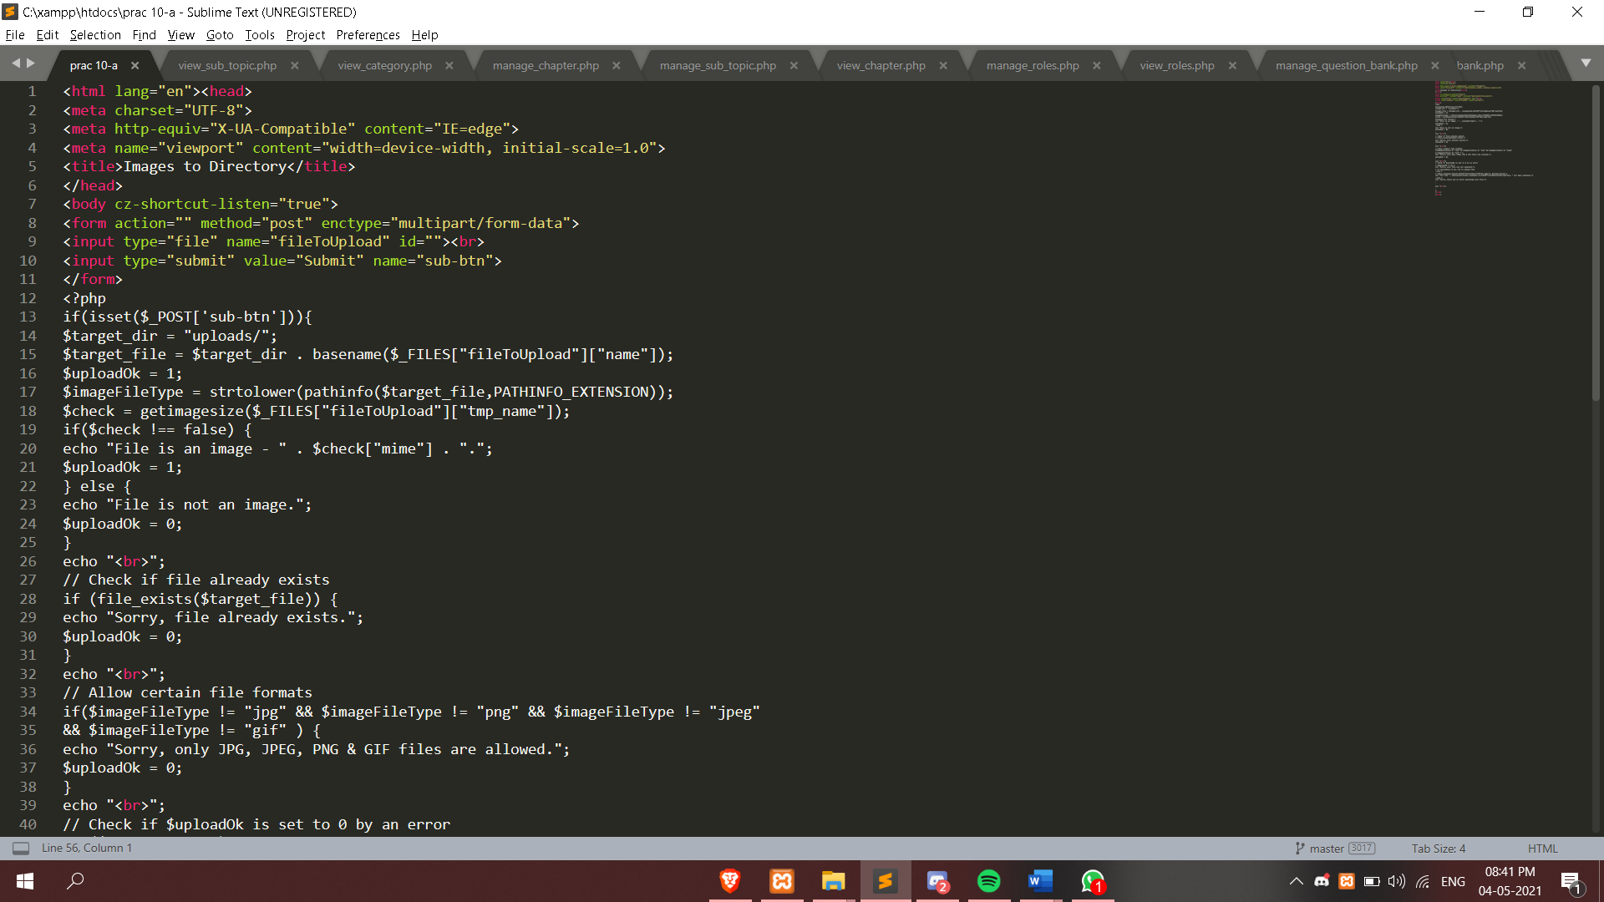

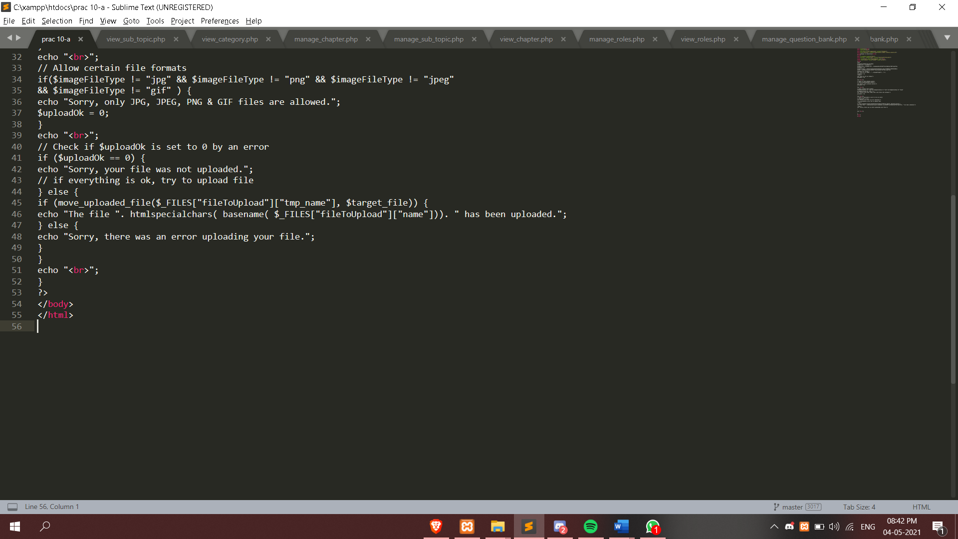

**10. B**

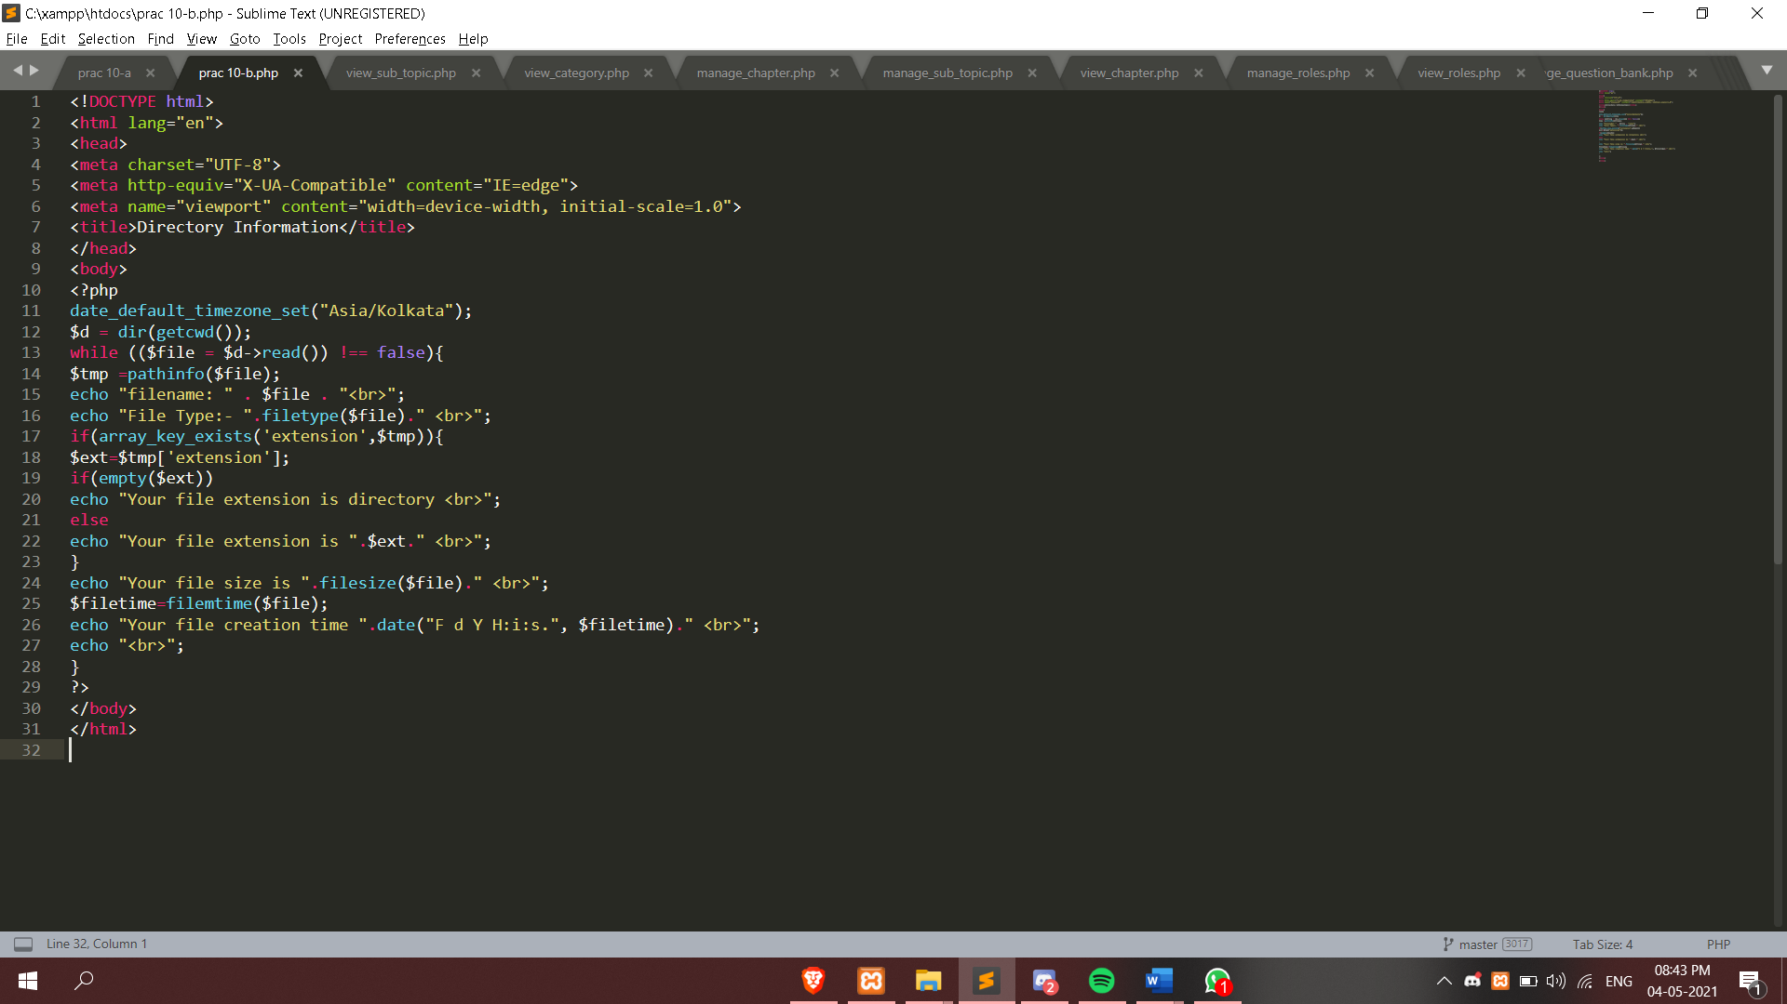

**10. C**

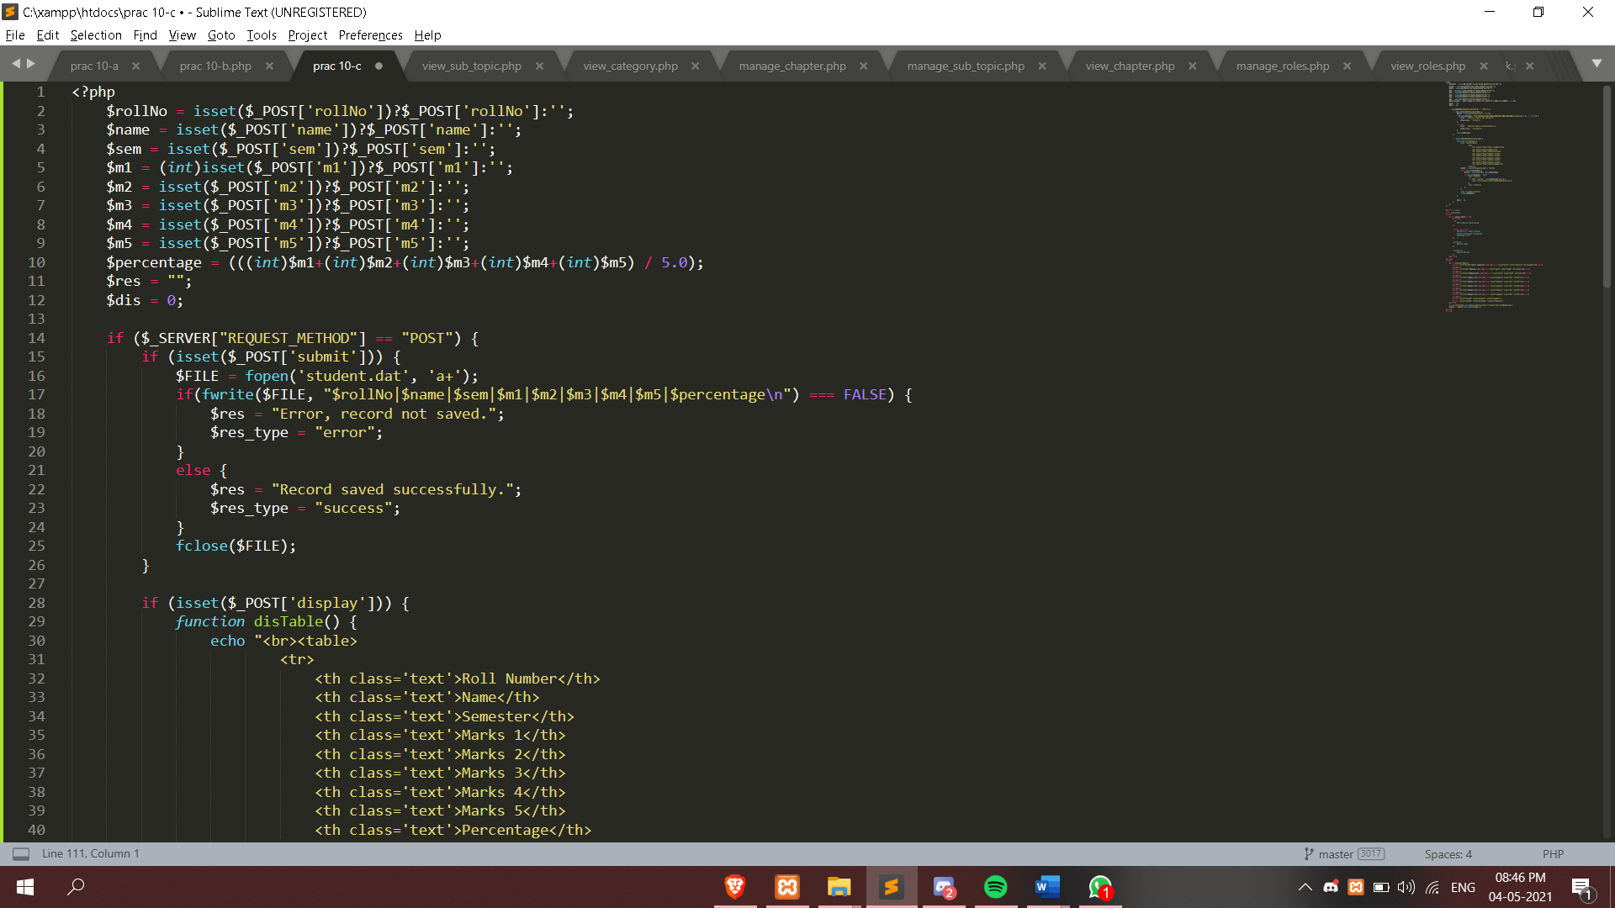

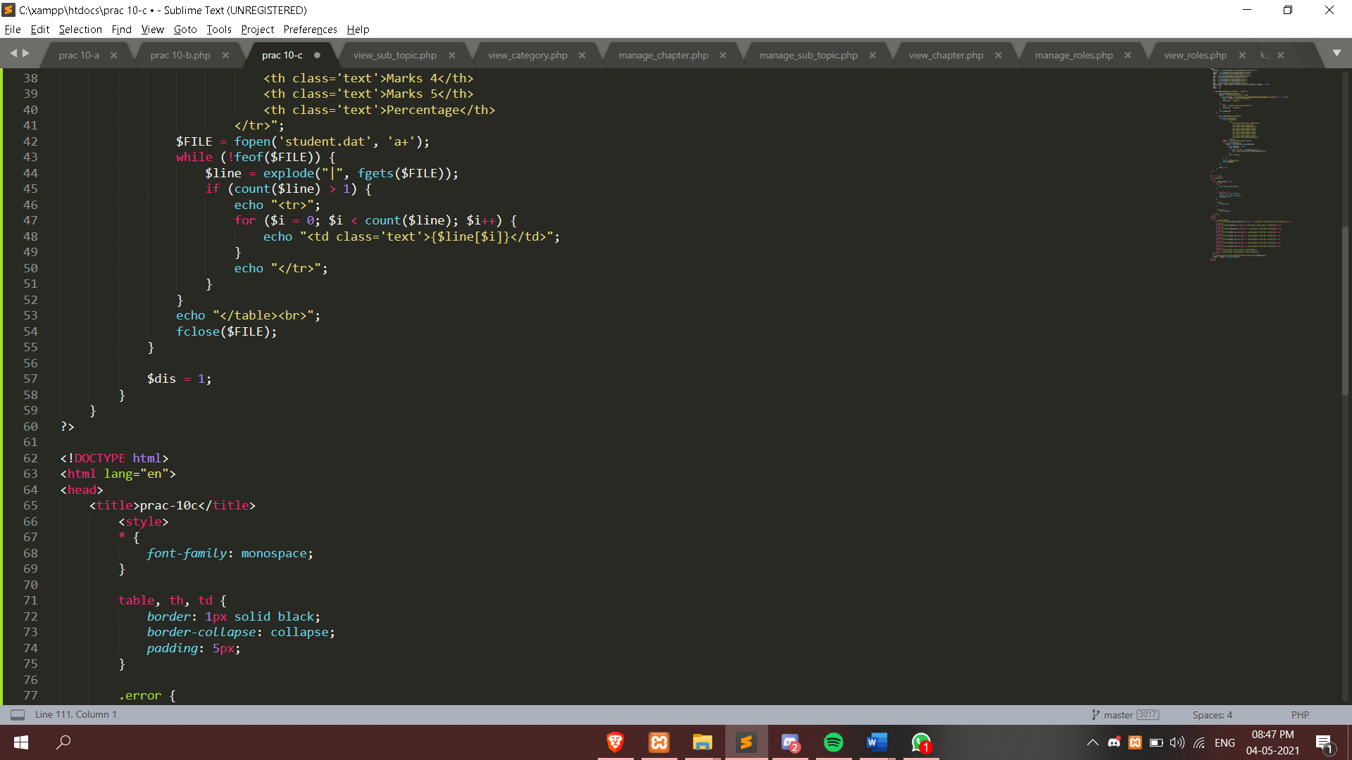

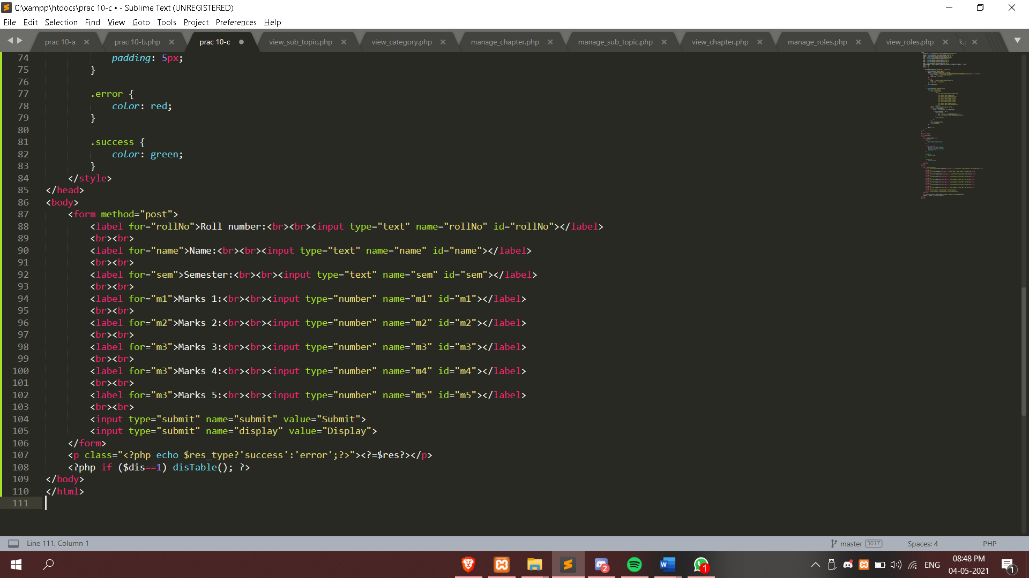

**Output:**

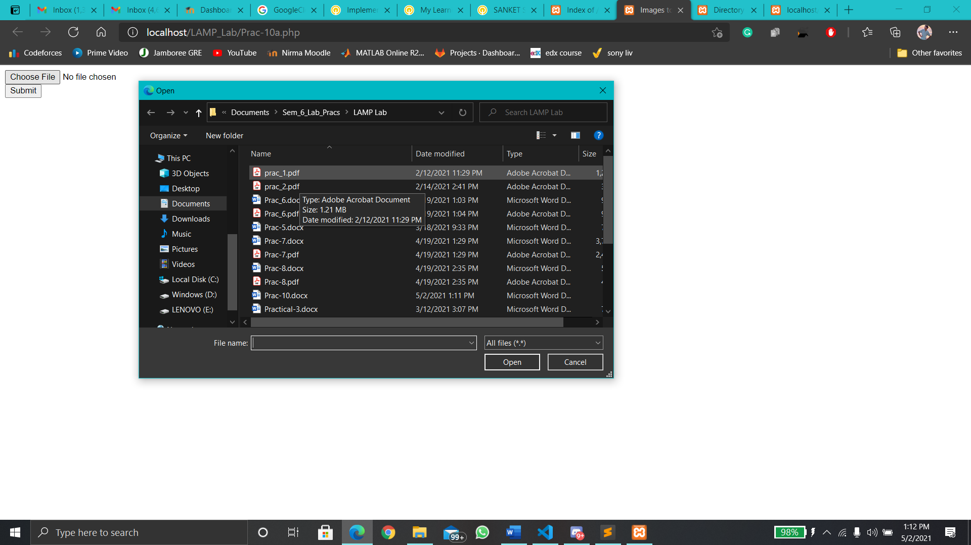

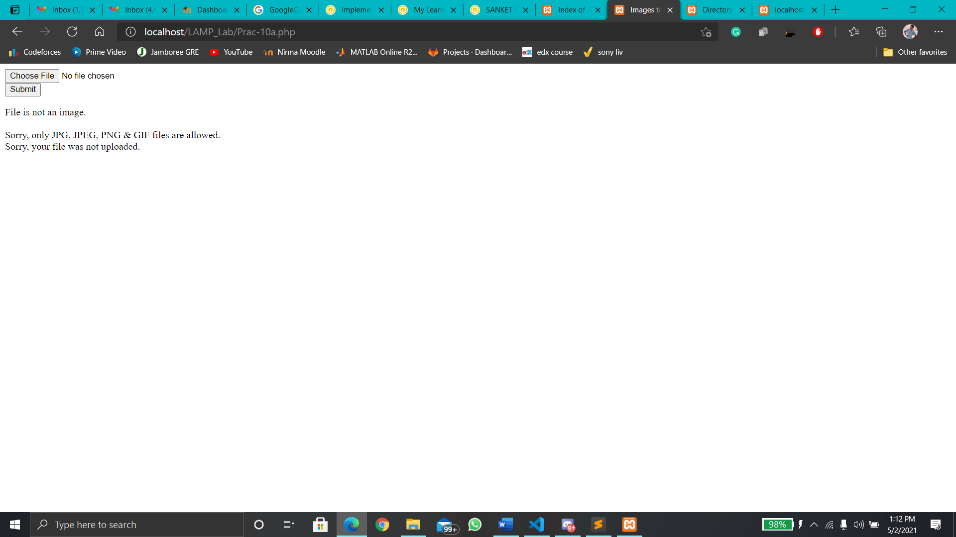

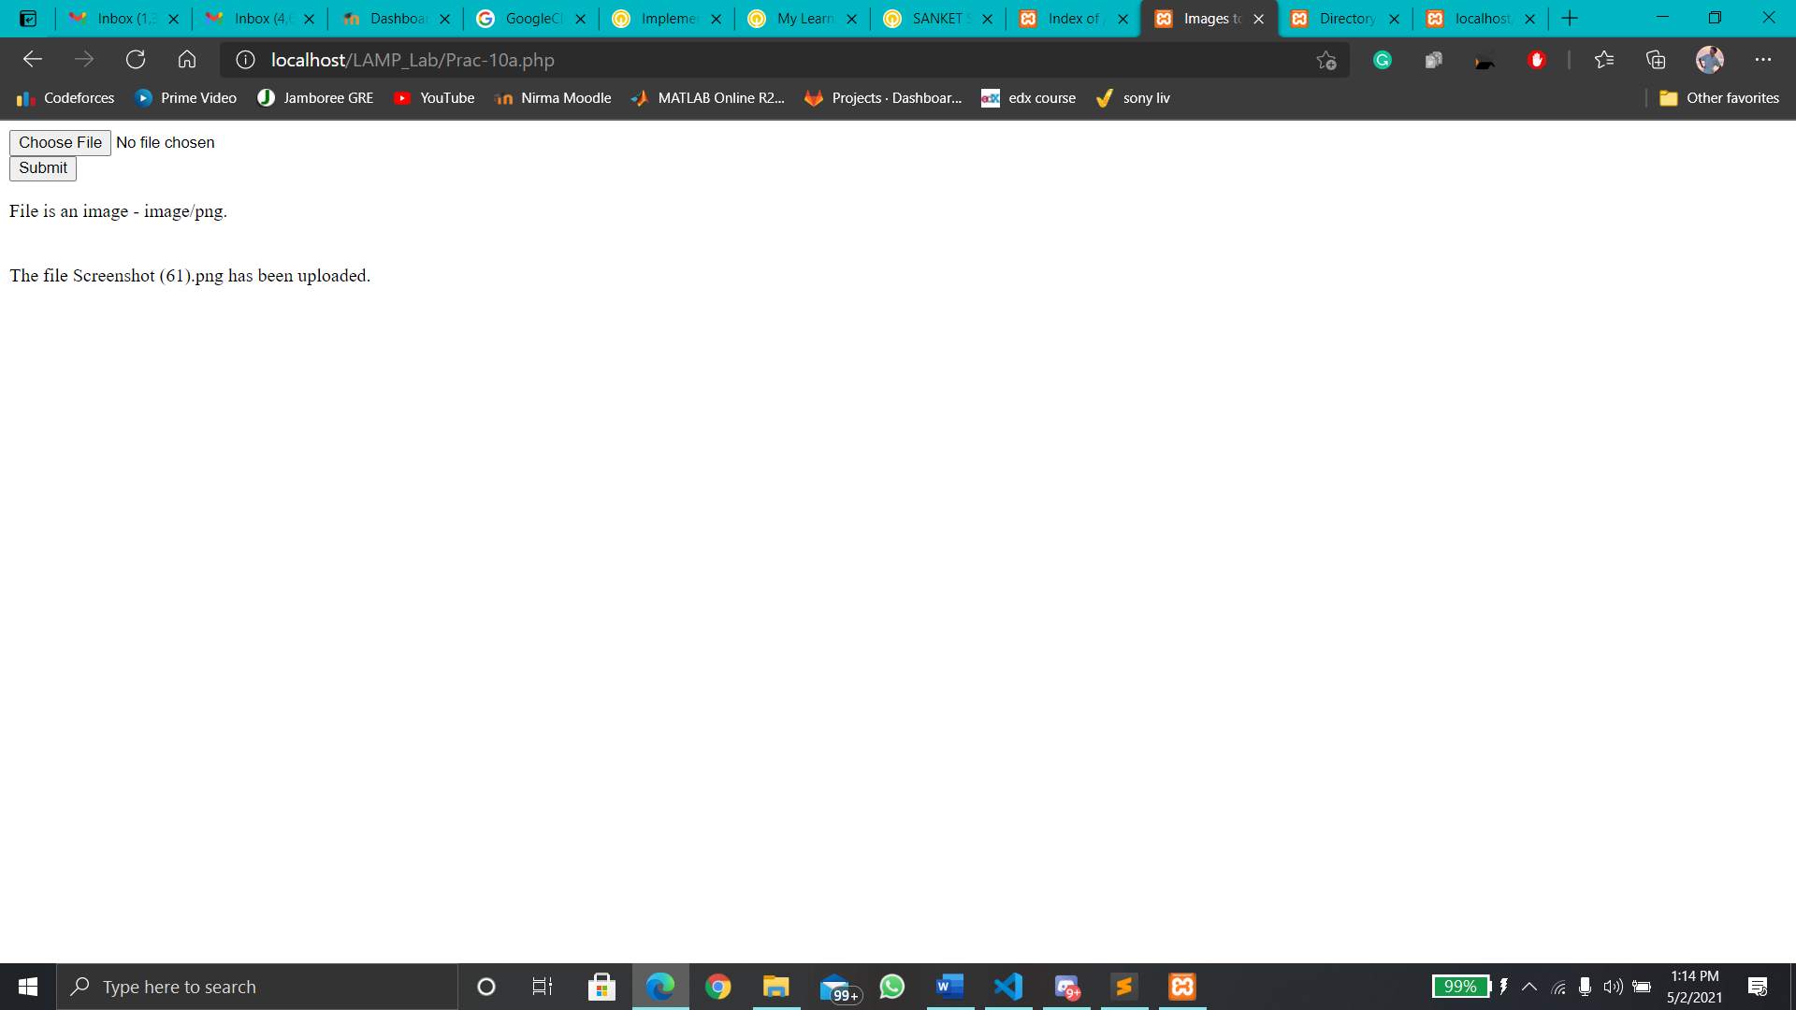

**Image is uploaded as shown below**

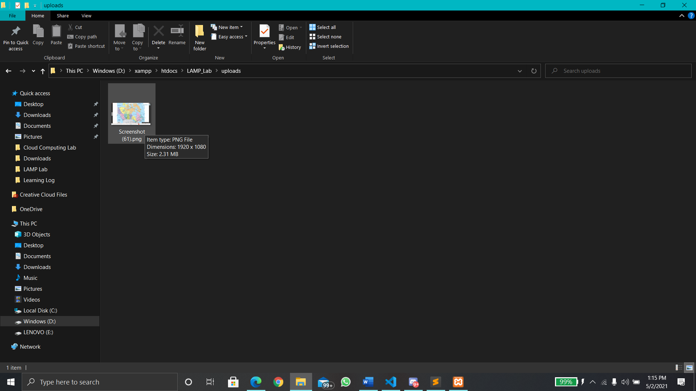

**10. B**

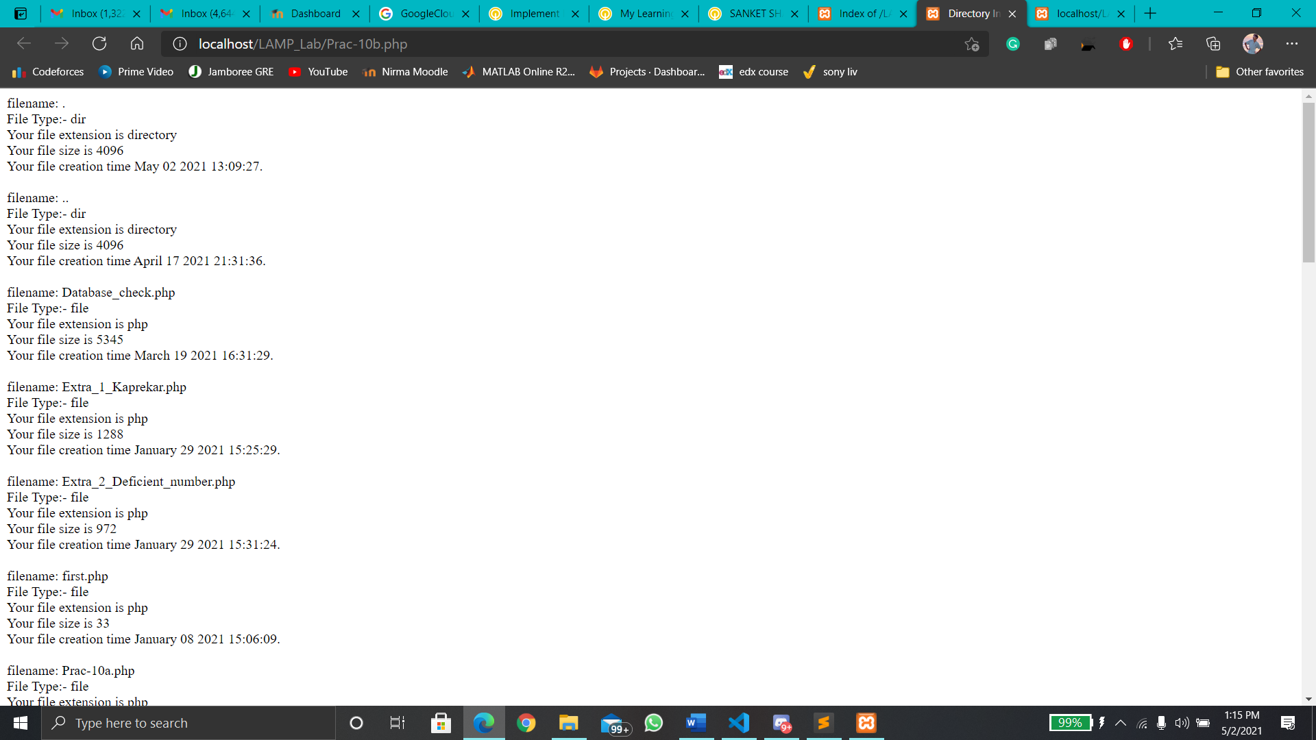

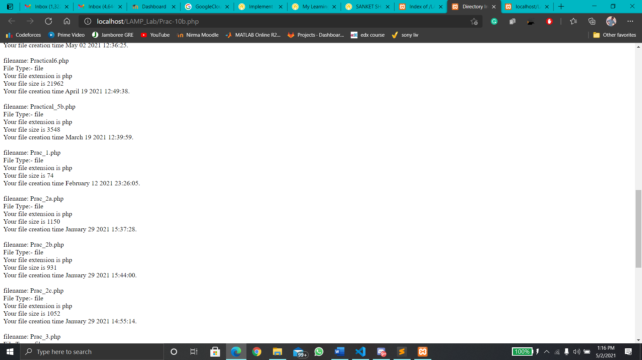

**10. C**

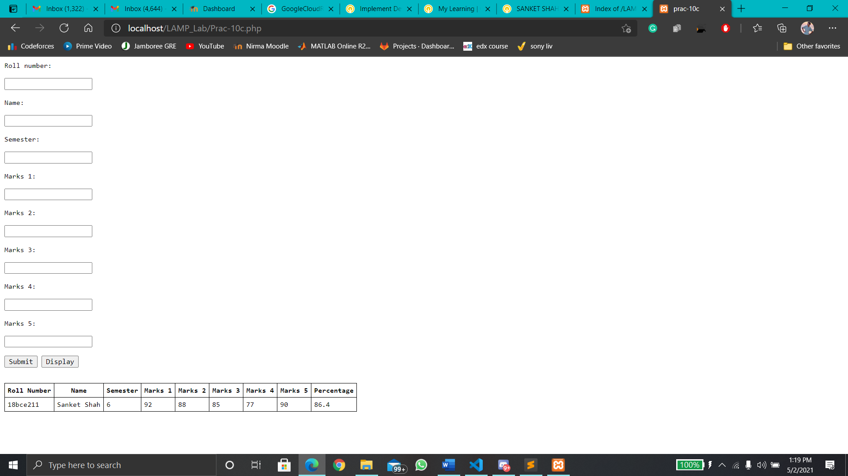

**The student.dat file is created**

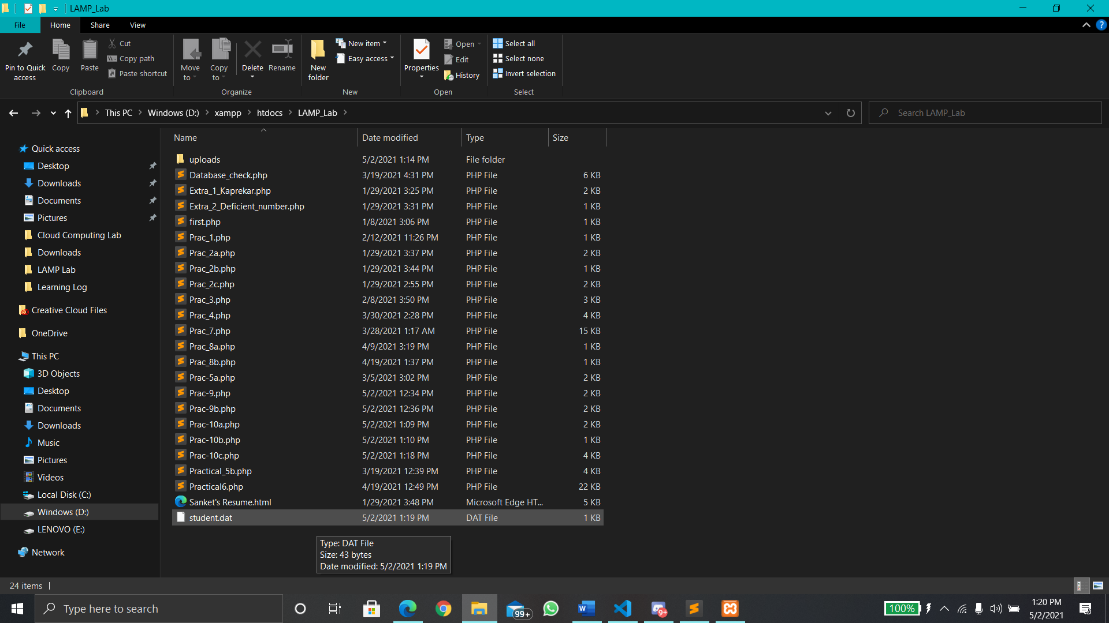

**Conclusion:**

**In this practical File Handling was performed and various functions were implemented.** **We learnt how to read data from files, how to write data to files and how to append data to files.**